**  **

**TECHSAKSHAM**

**Final project Report**

**Track name**

**Organ Donation Application**

**RAYALASEEMA UNIVERSITY COLLEGE OF ENGINEERING ;KURNOOL**

**NAMES**

* **T. SUVANA [19RU1A0544]**
* **G. TEJSWANI [19RU1A0518]**
* **P.AKHILA [19RU1A0539]**

**ABSTRACT**

Organ donation provides to be a life saving component in case of on emergency requirement. The aim of developing this online application to reduce the time to great extent, searching the right donor and the availability of organs required to save the patient. Fake I’d are prohibited. And it is very secured. The donor and the receivers will register through this application/site by filling the details by uploading their medical report. Organ donation as we all know is a good cause and can save many lives but in a developing country like India it is still not that popular. Although, the rate of donation has been increasing from the past few years but it is still not enough as only 0.01% of people donate their organs after death [1]. The main reason is lack of awareness and this android application is to create awareness among people. This Android application aims at linking the donors or wanting to be donors to the seekers. The donors and the seekers will register through the app by filling the details about themselves and by uploading their medical reports. The donor will have to upload the donor card as well. The phone number will be verified by One Time Password (OTP). All the data is being stored in the Database. Our application mainly fulfils the purpose of urgency of an organ when required by the patient and puts all the functionality and connection between our donor and recipient.

**ORGAN DONATION IMPORTANTANCE**

The organ donation day campaign, which is celebrated every year at August 13th provides a great opportunity in everyone’s life to come ahead and pledge to donate their precious organs.

**WHAT IS ORGAN DONATION?**

Organ donation is the gift of on organ to a person who needs transplant to improve is condition and health status. It is a producer in which a health organ(donor) is taken from on individual who is either living deceased and is transplanted into a person whose respective person malfunctioning.

**TABLE OF THE CONTENT**

1. **NO TITLE PAGE NO**

Acknowledgement

Abstract 1

List of Content 2

List of Figures 3

Photographs

1. **Introduction 4**
2. **Overview 6**
3. **Literature Survey 7-8**
4. **System Analysis 9**
5. **System Design and Implementation 10**

5.1 Requirements

5.1.1 Hardware Requirements 10-11

5.1.2 Software Requirements 11-13

5.2 UML Diagram 14-20

5.3 Project Implementation

1. **Testing 21-23**
2. **Results 24-30**
3. **Conclusions 31**
4. **Reference 32-33**

**List of Figures**

**S.NO FIGURE NAME PAGE NO**

1. Flow chart 14
2. Use case Diagram 15
3. Class Diagram 17
4. Sequence Diagram 18
5. Activity Diagram 19
6. flow Diagram 20
7. Interaction Graph
8. App View 24
9. Personal Information Page 25
10. Medical Data 26-27
11. Detail Page 28
12. Acknowledgement Page 29
13. Submit Bar 30
14. **INTRODUCTION**

Organ Donation-A Gift of Life

Organ Donation is donating a donor’s organs like heart, liver, kidney, intestines, lungs, and pancreas after the donor dies, for the purpose of transplanting them into other person who is in need of an organ. The organ of the donor can be transplanted to the patient who needs it urgently.

The organ donor can play a big role in saving other’s life. To increase the number of organ donors, especially among underrepresented populations, current approaches include the use of optimized social network inventions, exposing tailored educational content about organ donation to target social media users.

The act of giving one or more organs without compensation, for transplantation into someone else. Organ donation is a very personal yet complex decision, intertwined with medical, legal, religious, cultural, and ethical issues.

Some of the main causes are lack of awareness, religious and superstitious beliefs and strict laws. Some people are interested in this social cause but don't have enough knowledge as to what to do and how to donate. Another factor is, people are not literate enough to know the importance of this cause. So, we are providing our nation with an Organ Donation Android Application to spread awareness and give an easy facility to our people to save life

**Organ Donation and Transplantation**

Organ donation and transplantation is removing an organ from one person (the donor) and surgically placing it in another (the recipient) whose organ has failed. Organs that can be donated include the liver, kidney, pancreas and heart.

Organ transplantation is one of the great advances in modern medicine. Unfortunately, the need for organ donors is much greater than the number of people who actually donate. Every day in the United States, 21 people die waiting for an organ and more than 107,380 men, women and children await life-saving organ transplants.

**Facts about Organ Donation**

* Anybody can be an organ donor irrespective of their age, caste, religion, community etc
* There is no defined age for donating organs. The decision to donate organs is based on strict medical criteria, not age.
* Tissues such as cornea, heart valves, skin, and bone can be donated in case of natural death but vital organs such as heart, liver, kidneys, intestines, lungs, and pancreas can be donated only in the case of ‘brain death’.
* Organs such as the heart, pancreas, liver, kidneys and lungs can be transplanted to those recipients whose organs are failing because it allows many recipients to return to a normal lifestyle.
* Anyone younger than age 18 needs to have the agreement of a parent or guardian to be a donor.

1. **OVERVIEW**

The decision to donate organs is based on strict medical criteria, not age. Tissues such as cornea, heart valves, skin and bone can be donated in case of natural death but vital organs such as heart, liver, kidneys, intestines, lungs and pancreas can be donated only in the case of ‘brain death’.

In this project, the main aim is to reducing the time and increasing the rate of saving lives. This application is free of cost and anyone can register if they have the thought of donating their organs without commencement.

**Steps of the Organ Donation process**

* Identification of the potential donor by the hospital.
* Evaluation of donor eligibility.
* Authorization for organ recovery.
* Medical maintenance of the patient.
* Matching organs to potential recipients.
* Offering organs regionally, then nationally.
* Placing organs and coordinating recovery.

FUTURE SCOPE In future we can use the technique of machine learning and artificial intelligence for reading the medical prescription and reports and carry out the major matching between donor and recipient through the application itself. It can be the most self evolved application which can read the medical report and can find matches by specially taking time of requirement as a major consideration.

1. **Literature Survey**

In India, not many android applications are available. There are hardly 2 to 3 apps that are currently being used or being made but still not available for the users on any app store. The genuineness of the seeker and the donor will be checked by the admin or a group of people. All the details and the uploaded reports of the users will be saved in the real time database. We are using the Firebase Real-time Database because it allows a secure access to the database directly from the client-side code. For about 160,000 patients who need organs, there are only 12,000 donors available. While there are no exact figures but while researching, we get to know that there is a need of about 1.5 to 2 lakh kidney transplants a year, but only about 8,000 transplants happen. Also, as about 40,000-50,000 liver transplants require a year, about 1,700-1,800 happen each year. Estimates also say that about 15,000 heart transplants are required a year but only about 250 heart transplants happen every year. These figures are so heartbreaking to see. Due to existing myths surrounding brain death and lack of awareness, people tend to waste the opportunity of saving the life of others, due to which there is a waste of organ donation.

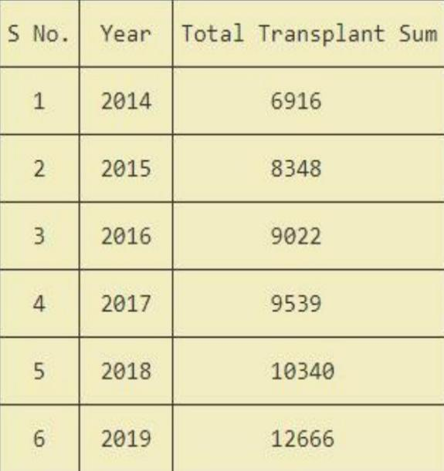

Organ transplantation table of India

Our application will be on the research which will follow all the government guidelines and rules which are necessary for the process of organ donation. For example, the Recipient should not know anything about donors or their details as it can also cause the crime like killing of Donors for organs so we will also keep it hidden from the recipients’ side, everything about the donors’ side. Our main motive is to increase the rate of organ donation per million in our country which is stated in the below table.

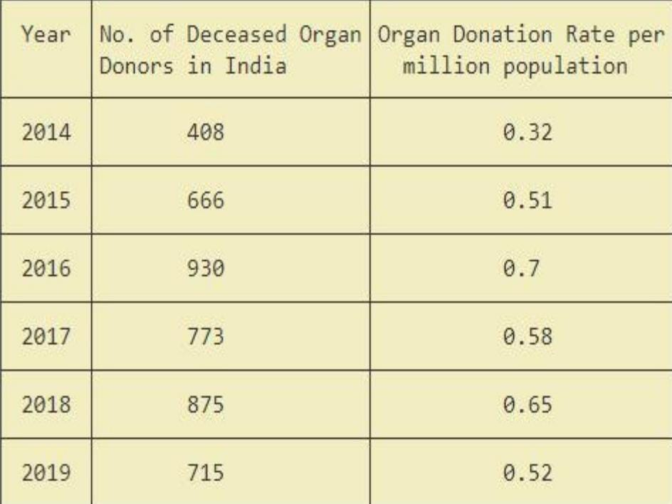

Organ Donation Rate per million in India

1. **System Analysis**

India the rate of organ donation per million is comparatively very low than other countries around the globe. People are not ready to donate due to misconceptions and there are very less donors as compared to seekers in our country. There is no such market opportunity in this application, it’s an application which is meant for the lifesaving purpose and will be a revolutionary step for saving the lives of our people.

People are allowed to donate organs but this application can be used by the people of age group of more than 18 years, who are ready to make their own decision that they want to be a part and be a donor or not. Any citizen of our country who carries an android smart phone can use this application, irrespective of their location. While referring to the other applications on organ donation we found a drawback that they were providing the details of the donor and recipient to each other which can result in dangerous crimes like killing for the need of an organ. This application aims at linking the donors or wanting to be donors to the seekers without telling the details of each other just by passing the urgent message requests from recipients to the donors. The donors and the seekers will register through the app by filling the details about themselves and by uploading their medical reports. The donor will have to upload the donor card as well. This application will be held under an authorized organization which will look after the database clearance and every report of it.

1. **System Design and Implementation**
   1. **Requirements**
      1. **Hardware Requirements**

**1. System** – I3 / Intel Processor Developed and manufactured by Intel, and first introduced and released in 2010, the Core i3 is a dual-core computer processor, available for use in both desktop and laptop computers. It is one of three types of processors in the "i" series (also called the Intel Core family of processors). The Core i3 processor is available in multiple speeds, ranging from 1.30 GHz up to 3.50 GHz, and features either 3 MB or 4 MB of cache. It utilizes either the LGA 1150 or LGA 1155 socket on a motherboard. Core i3 processors are most often found as dual-core, having two cores. However, a select few high-end Core i3 processors are quad-core, featuring four cores.

**2. RAM** – 8GB(minimum) RAM stands for “Random Access Memory”, it’s the physical part of the computer where it temporarily stores data for use by software. It’s a resource — programs use it, and there’s a finite amount of it. The more there is, the more space software has for working with data — it can also be used by the operating system to store frequently accessed data that is found in slower parts of the computer (like disks), which can increase the performance of the computer. If you run out of space, the computer has to do it’s best to figure out how to clean up and make room, if it can.8 GB stands for 8 gigabytes. A gigabyte is a measure of a quantity of information. Everything in a computer is just represented as a bunch of on/off positions of impossibly small switches, we write 0 for off and 1 for on — binary, or binary digits (shortened to “bits”). A byte is equal 8 bits - the amount of bits necessary to have enough combinations to represent every letter in the latin alphabet in upper and lower case, every digit, and all the basic punctuation symbols; a byte is the amount of data that a single letter takes up. “Giga” is the metric prefix for “billion”, so 8 gigabytes is an amount of space that can hold 8 billion letters.

**3. Hard Disk** – 160GB A hard disk drive (HDD), hard disk, hard drive, or fixed disk[b] is an electro-mechanical data storage device that stores and retrieves digital data using magnetic storage and one or more rigid rapidly rotating platters coated with magnetic material. The platters are paired with magnetic 12 heads, usually arranged on a moving actuator arm, which read and write data to the platter surfaces.[2] Data is accessed in a random-access manner, meaning that individual blocks of data can be stored and retrieved in any order. HDDs are a type of non-volatile storage, retaining stored data even when powered off.[3][4][5] Modern HDDs are typically in the form of a small rectangular box.

**5.1.3 Software Requirements**

**1. Android Studio**

Android Studio is the official integrated development environment (IDE) for Android application development. It is based on the IntelliJ IDEA, a Java integrated development environment for software, and incorporates its code editing and developer tools.To support application development within the Android operating system, Android Studio uses a Gradle-based build system, emulator, code templates, and Github integration. Every project in Android Studio has one or more modalities with source code and resource files. These modalities include Android app modules, Library modules, and Google App Engine modules.

**2. Windows 10 operating system**

Windows 10 is a major release of Microsoft's Windows NT operating system. It is the direct successor to Windows 8.1, which was released nearly two years earlier. It was released to manufacturing on July 15, 2015, and later to retail on July 29, 2015. Windows 10 was made available for download via MSDN and TechNet, as a free upgrade for retail copies of Windows 8 and Windows 8.1 users via the Windows Store, and to Windows 7 users via Windows Update. Windows 10 receives new builds on an ongoing basis, which are available at no additional cost to users, in addition to additional test builds of Windows 10, which are available to Windows Insiders. Devices in enterprise environments can receive these updates at a slower pace, or use long-term support milestones that only receive critical updates, such as security patches, over their ten-year lifespan of extended support. Microsoft announced that support for Windows 10 editions which are not in the Long-Term Servicing Channel (LTSC) will end on October 14, 2025. Windows 10 received generally positive reviews upon its original release. Critics praised Microsoft's decision to provide the desktop-oriented interface in line with previous versions of Windows, contrasting the tablet-oriented approach of Windows 8, although Windows 10's touchoriented user interface mode was criticized for containing regressions upon the touch-oriented 13 interface of its predecessor. Critics also praised the improvements to Windows 10's bundled software over Windows 8.1, Xbox Live integration, as well as the functionality and capabilities of the Cortana personal assistant and the replacement of Internet Explorer with Microsoft Edge. However, media outlets have been critical of the changes to operating system behaviors, including mandatory update installation, privacy concerns over data collection performed by the OS for Microsoft and its partners, and adware-like tactics used to promote the operating system on its release.

**3. Fire Base**

Firebase evolved from Envolve, a prior start up founded by James Tamplin and Andrew Lee in 2011. Envolve provided developers an API that enables the integration of online chat functionality into their websites. After releasing the chat service, Tamplin and Lee found that it was being used to pass application data that were not chat messages. Developers were using Envolve to sync application data such as game state in real time across their users. Tamplin and Lee decided to separate the chat system and the real-time architecture that powered it. They founded Firebase as a separate company in 2011 and it launched to the public in April 2012. Firebase's first product was the Firebase Realtime Database, an API that synchronizes application data across iOS, Android, and Web devices, and stores it on Firebase's cloud. The product assists software developers in building real-time, collaborative applications. Firebase has been claimed to be used by Google to track users without their knowledge. On July 14, 2020, a lawsuit was filed accusing Google of violating federal wire tap law and California privacy law. It stated that through Firebase, Google collected and stored user data, logging what the user was looking at in many types of apps, despite the user following Google's own instructions to turn off the web and app activity collected by the company.

**5.2 UML Diagram**

**Flow Chart**

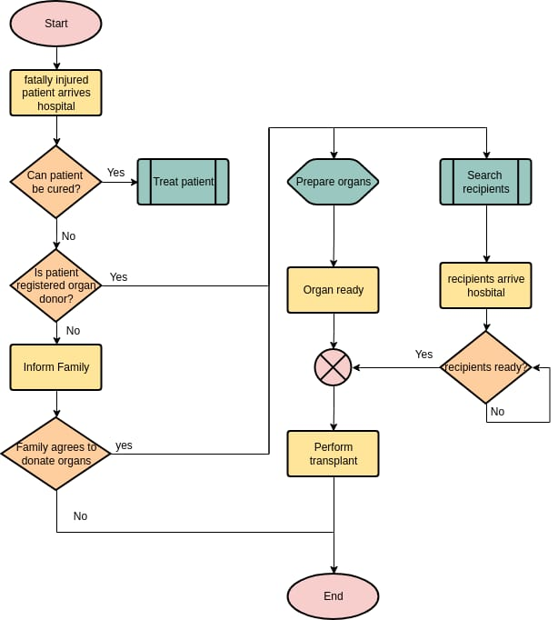

Fig 1 Flow Chat

**Use case Diagram**

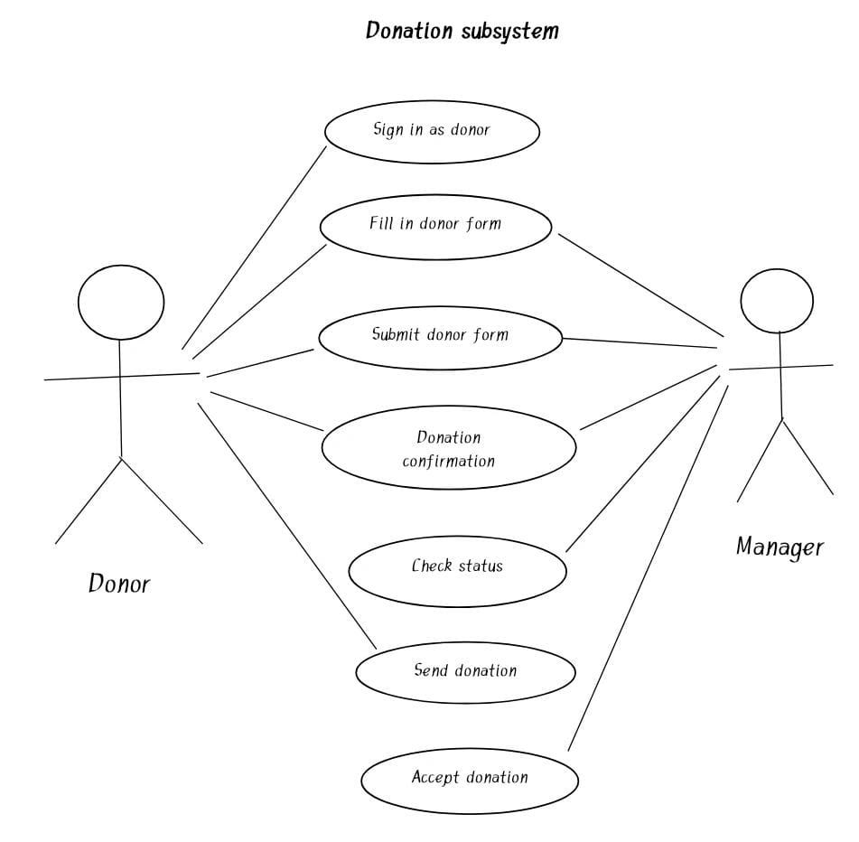

Fig 2 Use case diagram

A use case diagram is used to represent the dynamic behavior of a system. It encapsulates the system's functionality by incorporating use cases, actors, and their relationships. It models the tasks, services, and functions required by a system/subsystem of an application. It depicts the high-level functionality of a system and also tells how the user handles a system. The main purpose of a use case diagram is to portray the dynamic aspect of a system. It accumulates the system's requirement, which includes both internal as well as external influences. It invokes persons, use cases, and several things that invoke the actors and elements accountable for the implementation of use case diagrams. It represents how an entity from the external environment can interact with a part of the system.

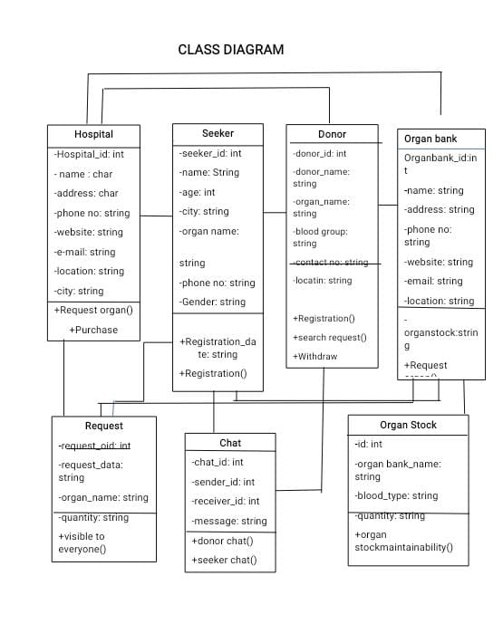

Class diagrams are the blueprints of your system or subsystem. You can use class diagrams to model the objects that make up the system, to display the relationships between the objects, and to describe what those objects do and the services that they provide. Class diagrams are useful in many stages of system design.

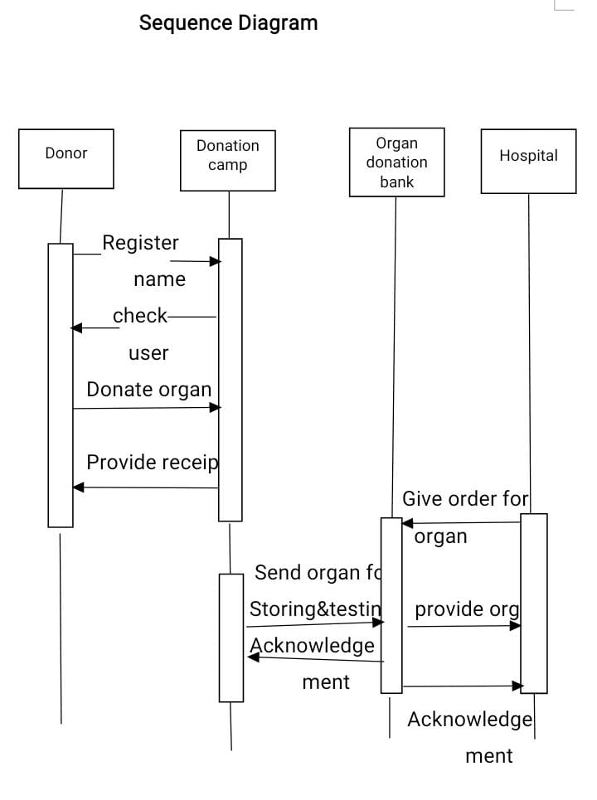

Sequence Diagrams are interaction diagrams that detail how operations are carried out. They capture the interaction between objects in the context of a collaboration. Sequence Diagrams are time focus and they show the order of the interaction visually by using the vertical axis of the diagram to represent time what messages are sent and when. The objects involved in the operation are listed from left to right according to when they take part in the message sequence.

**Activity Diagram**

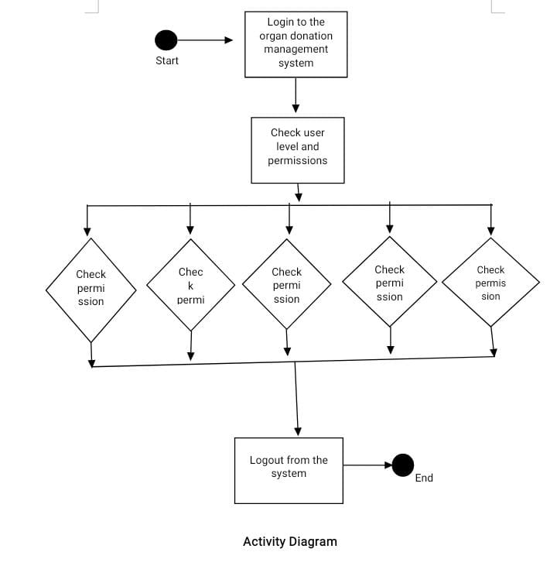

Activity diagram is basically a flowchart to represent the flow from one activity to another activity. The activity can be described as an operation of the system.The control flow is drawn from one operation to another. This flow can be sequential, branched, or concurrent. Activity diagrams deal with all type of flow control by using different elements such as fork, join, etc.

**Data Flow Diagram**

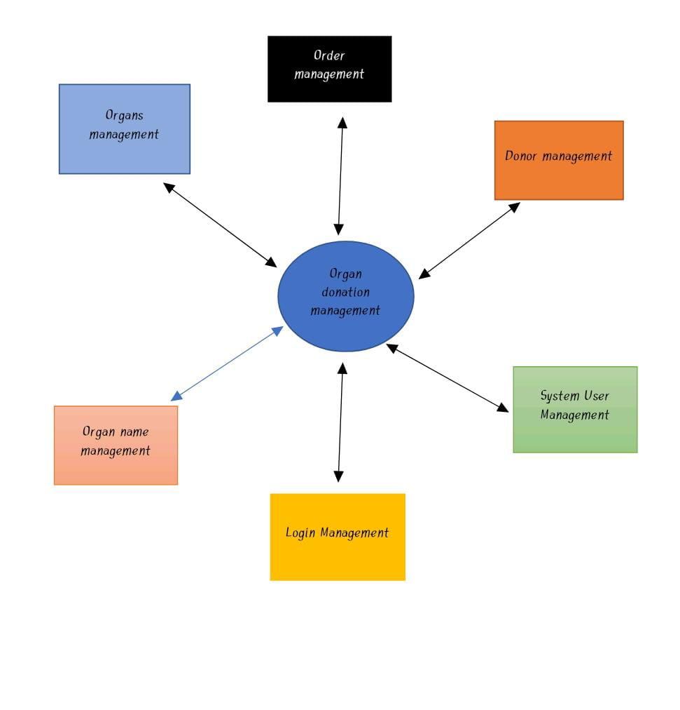

A data flow diagram (DFD) is a graphical or visual representation using a standardized set of symbols and notations to describe a business's operations through data movement. They are often elements of a formal methodology such as Structured Systems Analysis and Design Method.

1. **TESTING**

**1. White Box Testing**

White box testing is an approach that allows testers to inspect and verify the inner workings of a software system—its code, infrastructure, and integrations with external systems. White box testing is an essential part of automated build processes in a modern Continuous Integration/Continuous Delivery (CI/CD) development pipeline.

White box testing is often referenced in the context of Static Application Security Testing (SAST), an approach that checks source code or binaries automatically and provides feedback on bugs and possible vulnerabilities.

**Type of White box testing**

**a) Unit testing** — tests written as part of the application code, which test that each component is working as expected.

**b) Mutation testing** — a type of unit testing that checks the robustness and consistency of the code by defining tests, making small, random changes to the code and seeing if the tests still pass.

**c) Integration testing** — tests specifically designed to check integration points between internal components in a software system, or integrations with external systems.

**d) White box penetration testing** — an ethical hacker acts as a knowledgeable insider, attempting to attack an application based on intimate knowledge of its code and environment.

**e) Static code analysis** — automatically identifying vulnerabilities or coding errors in static code, using predefined patterns or machine learning analysis. 38 Pros and Cons of white box.

**Pros and Cons of white box testing**

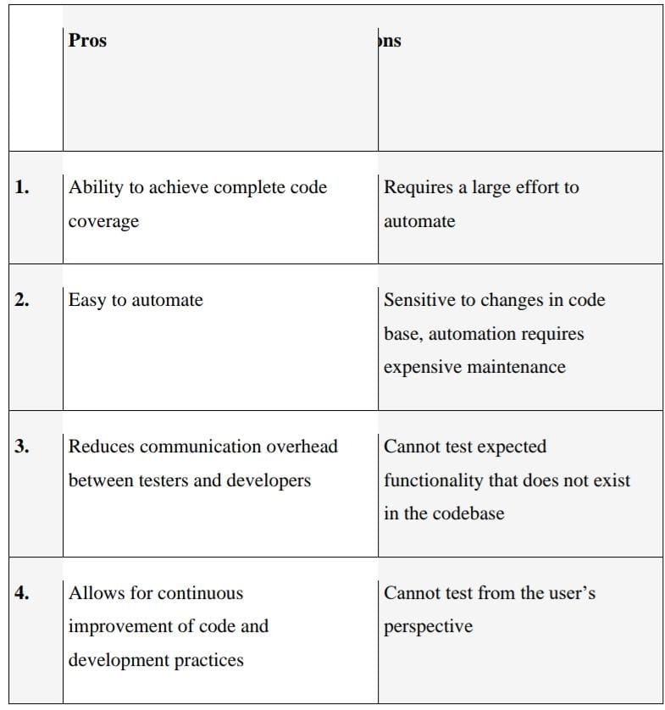

**2. Black box Testing**

Black Box Testing is a software testing method in which the functionalities of software applications are tested without having knowledge of internal code structure, implementation details and internal paths. Black Box Testing mainly focuses on input and output of software applications and it is entirely based on software requirements and specifications. It is also known as Behavioral Testing.

**How to do BlackBox Testing**

Here are the generic steps followed to carry out any type of Black Box Testing.

a) Initially, the requirements and specifications of the system are examined.

b) Tester chooses valid inputs (positive test scenario) to check whether SUT processes them correctly. Also, some invalid inputs (negative test scenario) are chosen to verify that the SUT is able to detect them.

c) Tester determines expected outputs for all those inputs.

d) Software tester constructs test cases with the selected inputs.

e) The test cases are executed.

f) Software tester compares the actual outputs with the expected outputs.

g) Defects if any are fixed and re-tested.

**Types of Black Box Testing**

There are many types of Black Box Testing but the following are the prominent ones –

**a) Functional testing** – This black box testing type is related to the functional requirements of a system; it is done by software testers.

**b) Non-functional testing** – This type of black box testing is not related to testing of specific functionality, but non-functional requirements such as performance, scalability, usability.

**c) Regression testing** – Regression Testing is done after code fixes, upgrades or any other system maintenance to check the new code has not affected the existing code.

1. **Results**

The following is the online application for Organ Donation.

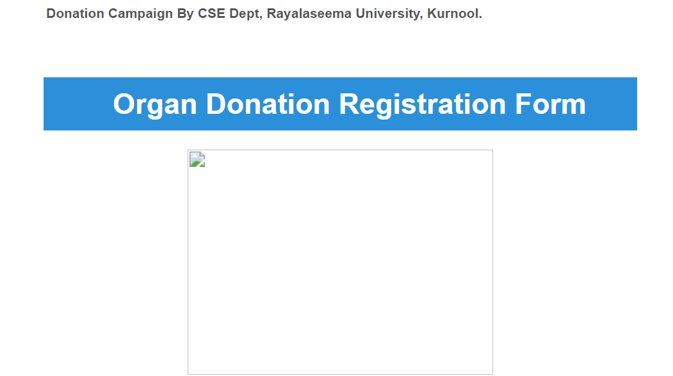

**Personal Information Page**

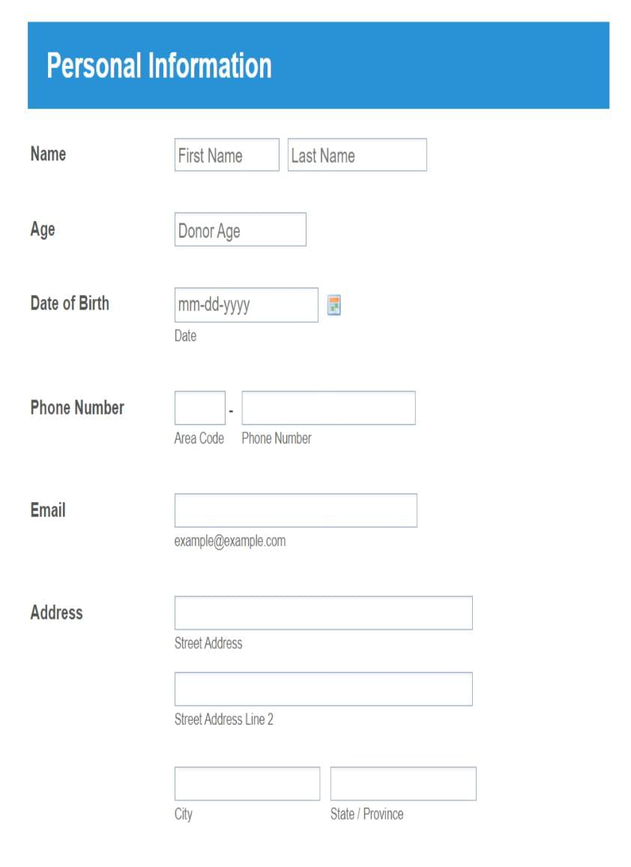

**Medical Data**

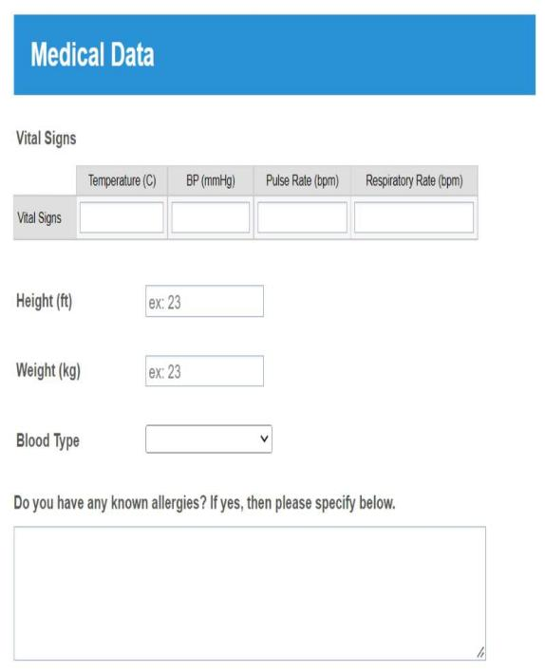

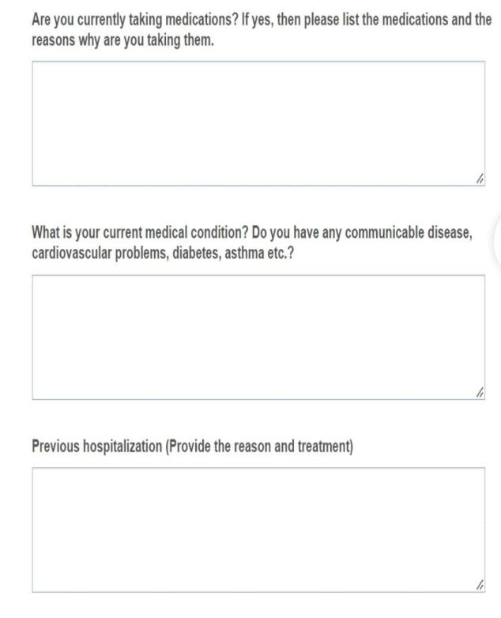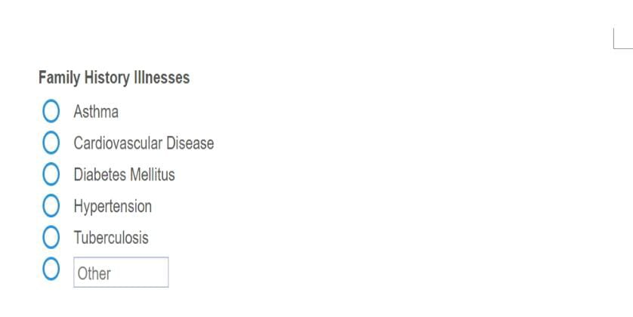

**Acknowledgement Page**

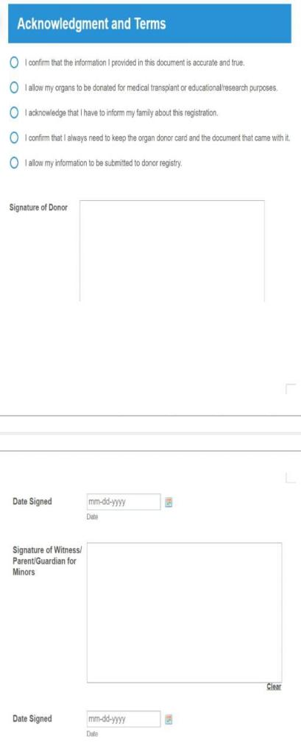

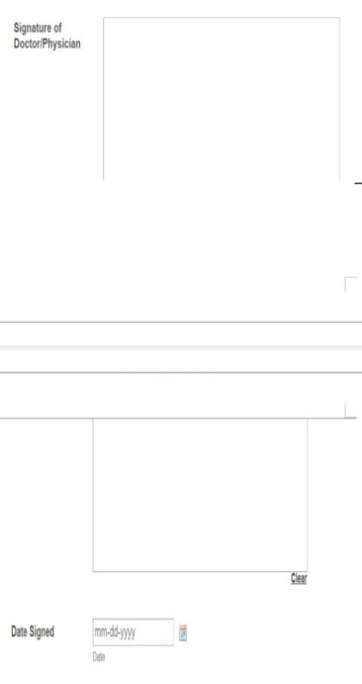

**Submit Bar**

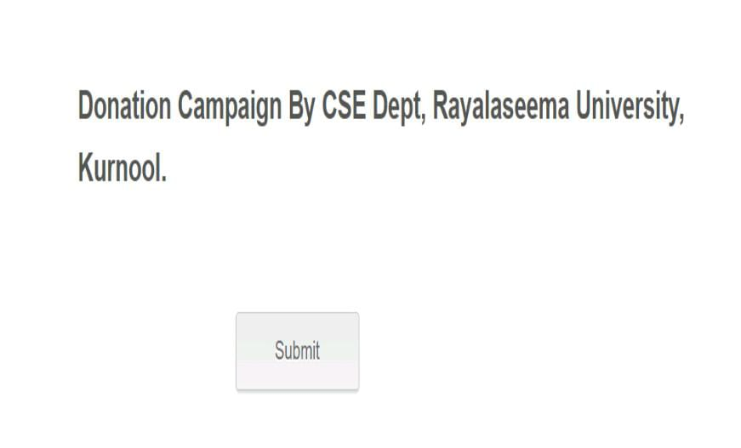

1. **CONCLUSION**

Organ donation by living donors clearly saves lives, improves transplantation outcomes under some circumstances, and reduces recipients’ waiting times. It also increases opportunities for patients without living donors to receive organs from deceased donors. However, it raises a series of ethical questions that have not been fully addressed. The transplantation of organs from living donors seems to violate the traditional first rule of medicine—primum non nocere (above all do no harm)—because it involves the removal of a healthy organ from one person for implantation into another person who is already a patient.

Although the committee believes that the whole practice of organ donation by living donors now needs a careful review and assessment on its own, in the interim the committee makes a few specific recommendations, building on ethical concerns and proposals already present within the transplantation community and drawing on the ethical perspectives that inform this report. These recommendations focus on the need for better information for improved risk-benefit analyses by transplantation teams, donor advocates, and potential donors themselves and on the increased use of independent donor advocate teams committed to the rights and welfare of the donor as patient, before, during, and after the donation.

This application will be the most user-friendly platform to enroll people in such good activity and will save many lives of the people who are dying due to lack of organ donation. It will create a long-term lifesaving role for every citizen in our country. Our prime target is to provide organs to the seeker when they are in need and make it a life saver platform for those who are dying due to the lack of organs and also targets the human race and spreads the concept of saving life after one's death.

1. **Reference**

1)<https://en.wikipedia.org/wiki/Organ_donation_in_India#Deceased_organ_donation_by_state>

2) LAKSHMISRI SURYA , "STREAMLINING CLOUD APPLICATION WITH AI TECHNOLOGY", IJIERT - International Journal of Innovations in Engineering Research and Technology, Volume 5 Issue 10, ISSN : 2394-3696, Page No. 23-28

3) Sudhir Allam, "RESEARCH ON THE SECURE MEDICAL BIG DATA ECOSYSTEM BASED ON HADOOP", International Journal of Creative Research Thoughts (IJCRT), ISSN:2320-2882, Volume.7, Issue 1, pp.815-819, March 2019, Available at :http://www.ijcrt.org/papers/IJCRT1133997.pdf

4) <https://www.indiatoday.in/mail-today/story/india-s-organ-crisis-deepens-1634029-2020-01-05>

5) <https://www.indiatoday.in/education-today/gk-current-affairs/story/organ-donation-body-parts-you-candonate-donor-laws-1576069-2019-08-01>

6) Ravi Teja Yarlagadda, "Implementation of DevOps in healthcare systems", International Journal of Emerging Technologies and Innovative Research (www.jetir.org), ISSN:2349-5162, Vol.4, Issue 6, page no.537-541, June-2017, Available :http://www.jetir.org/papers/JETIR1706100.pdf

7) <https://www.organindia.org/deceased-organ-donation-data/>

8) Sudhir Allam, "THE IMPACT OF ARTIFICIAL INTELLIGENCE ON INNOVATION- AN EXPLORATORY ANALYSIS", International Journal of Creative Research Thoughts (IJCRT), ISSN:2320-2882, Volume.4, Issue 4, pp.810-814, October 2016, Available at : <http://www.ijcrt.org/papers/IJCRT1133996.pdf>

9) AN ANDROID APPLICATION FOR BLOOD AND ORGAN DONATION MANAGEMENT” by Department of Computer Science and Engineering, RMK Engineering College, Kavaraipettai, Chennai, Tamil Nadu, India-IRJET Volume: 06 Issue: 03 | Mar 2019

10) Lakshmisri Surya,Ravi Teja Yarlagadda, "AI ECONOMICAL SMART DEVICE TO IDENTIFY COVID-19 PANDEMIC, AND ALERT ON SOCIAL DISTANCING WHO MEASURES", International Journal of Creative Research Thoughts (IJCRT), ISSN:2320-2882, Volume.8, Issue 5, pp.4152-4156, May 2020, Available at :http://www.ijcrt.org/papers/IJCRT2005556.pdf

11) Sudhir Allam, "BIG DATA MIGHT JUST CURE CANCER - THE RESEARCH AND THE REALITY", International Journal of Creative Research Thoughts (IJCRT), ISSN:2320-2882, Volume.7, Issue 4, pp.820-825, December-2019, Available at :http://www.ijcrt.org/papers/IJCRT1133998.pdf

12) “BLOOD AND ORGAN FOR PATIENT USING ANDRIOD APPLICATION” by Department of Information Technology, Dr. Bhausaheb Nandurkar College of Engineering & Technology, Yavatmal, Maharashtra, India-IRJET eISSN: 2319-1163 | pISSN: 2321-7308.